How to play: Bomb Crypto

1. Game Introduction

Bomb Crypto is a play-to-earn game where players manage a group of robot bomb heroes, which can be programmed to search for BCOINs and fight monsters. Each bomb hero has different stats, and if players are lucky, they can find bomb heroes with good stats to sell or upgrade, thus improving their performance and combat effectiveness.

Each Bomber Hero is a tradable NFT that players own. Players can also find other NFT items such as wearable equipment.

Manage bomber heroes, explore the game world together, defeat monsters and bosses, free kingdoms attacked by monsters, and earn tokens.

Official website:

https://bombcrypto.io/

Official Twitter:

<https://twitter.com/BombCryptoGame>

1. Basic Information

Game Token: BCOIN

Current token price: $0.556

0.4343 (2022-02-11)

First release method IDO

Affiliated public chain BscScan

Maximum supply 100,000,000 BCOIN

Maximum supply market cap $56.17 million

Current supply 100,000,000 BCOIN

Current supply market cap of $56.17 million

Listed on 8 exchanges

Number of holding addresses is 802,761

1. Game Heroes

* Bomb Hero
* Henricus: Warrior + Shield
* Bully Frog: Long Tongue + Jump
* Richard: Gunner + Quick Healing
* Jasper Vampire: Hypnosis + Flexible Movement
* Magic Yaga: Witch + Support

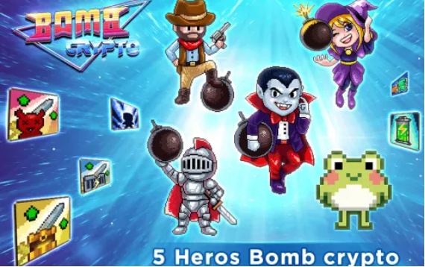

* Collect Heroes

Bomb heroes can be collected from rescue missions, store purchases, and market purchases.

▲Rescue Missions

Players can acquire new heroes from rescue missions.

If the player is lucky, they can find heroes locked in a prison block. If the player breaks the prison block, they can get the hero for free.

Note: Prison blocks can only be found in Treasure Hunt mode. The speed of the prison cap has a time limit.

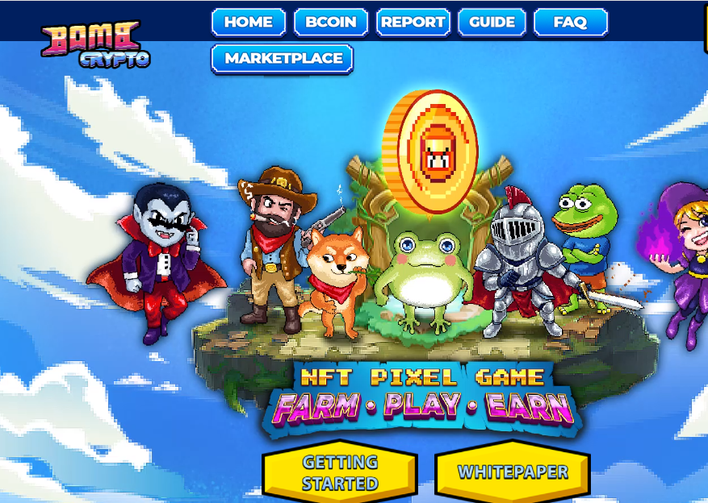

▲Store Purchases

Bomber heroes can be purchased from the in-game store using BCOIN. However, the number of heroes in stock is very limited. New heroes also take time to recover, just like rescue missions.

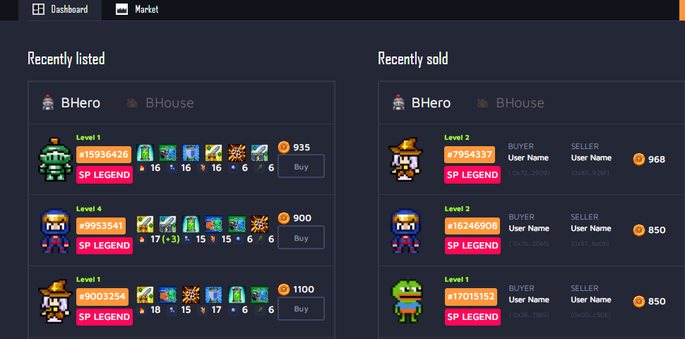

▲Market Purchases

A P2P marketplace that gives players the opportunity to buy and sell NFT items as well as bomb heroes themselves. This helps players earn a profit in the game and increase their game assets and liquidity. BCOIN is the only currency that can be used to purchase things on the market.

* Bomb Crypto Hero Upgrade Mechanism

Hero upgrades require 1 hero as a material, which will disappear after the upgrade.

Only heroes of the same level can be used to upgrade (the same rarity is not required) (e.g. common level 2 can be used to level up epic heroes)

The hero upgrade price increases according to the hero's level (for example, the price of a legendary level 1 hero will be higher than the price of a rare level 1 hero). After the level is upgraded, only the damage attribute is upgraded by 1, and the other attributes remain unchanged.

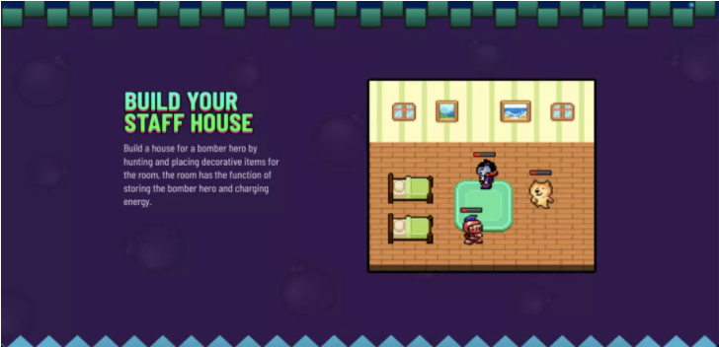

Bomb Crypto is a play-to-earn game where players manage a team of robot bomb heroes that are programmed to search for BCOINs and fight monsters. Each bomb hero has different attributes. If players are lucky, they can find bomb heroes with good attributes which can be sold for a profit or upgraded to obtain higher attributes and combat power.

Commanding bomb heroes and exploring the world together is the essence of this game. Defeat monsters and bosses, free kingdoms attacked by monsters, and earn game experience and rewards together.

1. Game Modes

* Home Decoration Mode (Increase Buffs)

Players can build houses for their bomber heroes by finding and placing decorative items. The room stores the bomber hero and charges up their energy.

* Battle Mode

Players can choose a hero to join in bomb battles with many other players. Users have to pay a certain amount of tokens to participate in battle mode, and the winner receives all of the losers’ tokens. Bomber heroes also lose a certain amount of energy when participating in battle mode.

* Treasure Hunt Mode

In Treasure Hunt mode, players can send bomber heroes to mining areas so that they can place bombs to destroy blocks in search of BCOIN. These heroes can work automatically without requiring players to be present at all times. This saves players a lot of time so they can conduct other tasks.

Heroes also consume energy each time a bomb is placed. When their energy is depleted, the hero goes into a resting state to replenish their energy. Players can buy houses to increase the charging speed of energy.

* Story Mode

Players can choose their own bomber hero to participate in each level of the story mode. Players must destroy all the monsters at a certain level to pass it. Breaking blocks and killing monsters also gives players a chance to find BCOINs.

Playing a level also requires the bomber hero to expend energy. So, if they do not have enough energy, heroes cannot be selected for a level. In addition, when playing the game, if players encounter monsters they will also lose energy. If the hero's energy reaches zero, they lose the battle. In addition, the game has dramatic boss battles that provide players with many interesting NFT rewards.

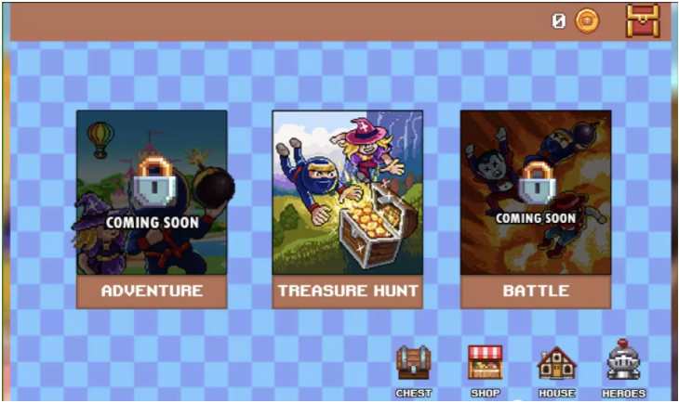

1. Token Economics

BCOIN is a BEP-20 token that allows token holders to play, exchange, invest, and become part of the game’s ecosystem development. BCOIN utilizes cryptocurrency assets with strong security, high liquidity, and convenient exchange. This helps users play, enjoy, and monetize the game. The total supply of BCOIN is fixed.

The following are some ways in which BCOIN can be used:

* Buy and upgrade game characters and items;
* Payments between users via in-game P2P marketplaces;
* Buy NFTs;
* Staking for powerful VIP privileges and rewards;
* Join the governing team to decide the future of the game;
* Reward enthusiastic community members;

Users can earn BCOIN by collecting items, taking part in tournaments, winning seasonal rewards, staking earnings, taking part in auction market sales, etc.

Token Distribution

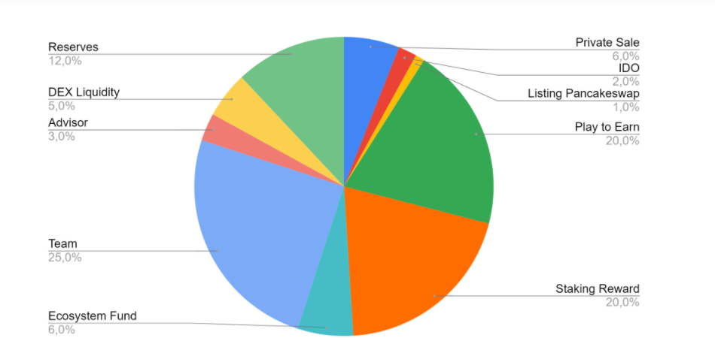

1. Roadmap

Q3 2021: Buying Heroes, Hero Stats and Upgrades, Hero Rescue, Home Buying, Treasure Hunt Mode

Q4 2021: Markets added, Story Mode added, new skins added

Q1 2022: House Decorations, VIP and Stakes, New Story Mode Levels

Q2 2022: New battle modes and leaderboards added

Q3 2022: Seek, Achieve

Q4 2022: New NTF items, new levels, new PvP maps added

